**WEEKLY PROGRESS REPORT**

**Sightline Capstone Project**

**Week 1**

**12 January 2019**

**Tai:**

**This week:**

Working on the SOW document on Github which includes

* Project timelines and Gantt chart
* Project requirements and specifications
* Rework first order estimator from Kimball
* Software requirements
* Do research and learn about Qgroundcontrol and Pixhawk 4

Group meeting

**Next week:**

* Continue and complete SOW
* Working on learning more about Pixhawk 4 and Qgroundcontrol
* Answer Jeremy general Q & A, as well as how to fly indoor safety for quadcopter

**Question:**

I was studying about PX4 autopilot and Qgroundcontrol, the MAVLink communication protocol is used to communicate between the Qgroundcontrol and Pixhawk 4 and Quadcopter. I tried to look for some resource about MAVLink, but I can’t find anything. I might be overcomplicated the problem. I would like to hear from you more about MAVLink.

**Kimball:**

**This Week:**

* Created SOW document on Github
* Researched project requirements, Pixhawk 4, 1500 OEM, SLA 1500-FFC, AR0134 optical sensor
* Created Level 0 block diagrams of current system and the desired configuration for the SOW
* Created first draft of hardware requirements for SOW

**Next Week:**

* Create spreadsheet for BOM
* Research component footprints available in Eagle, estimate time needed to create required footprints
* Continue researching IO for 1500 OEM, SLA 1500-FFC, and AR0134CS
* Continue researching Pixhawk 4 and quadcopter build

**Questions:**

* There are parts from the AR0134 development board that may be hard to find. The BOM listed several parts that needed to be created at a local machinist?

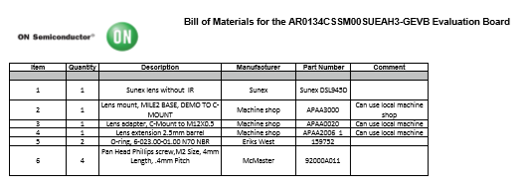

**Adel:**